|  |
| --- |
| BLISS: Blinking Low-Power Infrared Sensing System |

|  |
| --- |
| T. Miyamoto, CE, T. Molom-Ochir, EE, S. Rao, CE, and H. Shah, EE |

***Abstract* — The emergence of low-power wearable devices has enabled mobile health monitoring, wearable and sensor computing, applied machine learning, and physiological signal processing without relying on large processing units. However, despite the recent development of low power devices and energy constrained nature of these devices, there has not been a development of low cost, low power blink frequency and detection systems. In this report, we investigate the development of an energy efficient and low-cost blink frequency and duration sensing system BLISS. A two-part system, comprised of a pair of glasses in communication with a mobile application, was designed to make the system lightweight and to increase power endurance. Our results show that low-power high accuracy devices can be built using cheap electronic parts. We conclude that with the help of BLISS, we will be able to avoid drowsiness-related car accidents and serious conditions such as Computer Vision Syndrome.**

***Keywords: Drowsiness, Fatigue, Blinks, Eyeglasses, Eyelid***

# I. INTRODUCTION

## *A.* *Significance*

Wearable devices have revolutionized many fields of tech such as health monitoring, medicine, internet of things (IoT), activity recognition, tracking, and computer vision [1-4]. Although many wearable devices are fueled by on-device computing to provide insight into a variety of health conditions and physiological conditions, the development of a device that can provide information on the user's cognitive state with low latency has been lagging. A new generation of wearable devices is emerging with the main goal being providing cognitive state monitoring information whilst consuming low power and performing at low latency.

Our cognitive state provides important information about our level of attention, addictive behavior, quality of life, sleep quality, level of fatigue and drowsiness, and other health-related problems. A study from 2018 revealed that between 30% and 48% of older adults suffer from insomnia [5]. This coupled with the fact that about 50-70 million Americans suffer from chronic sleep deprivation indicates that we suffer from serious fatigue and inattention, given the association between short sleep duration and poor cognitive state [6, 7]. This is a serious emerging problem as it is directly connected to accidents that happen during tasks that require high attention and low level of fatigue, such as operating machinery. " According to the National Highway Traffic Safety Administration, in 2020, there were 633 police-reported, drowsy-driving deaths [8]. Moreover, a 2019 study done on the contribution of driver distraction and inattention within fatal and injury crashes revealed that 31.3% of crashes revealed that driver inattention contributed to the crash [9]. When it comes to inattention, behaviors of inattention consistently predicted lower academic performance [10]. As statistics show, fatigue and inattention are serious contributing factors to any high attention-based tasks. We don’t only suffer from this problem; in this day and age, with the rise of electronic devices which have screens, we also suffer from ocular-related problems. Among engineering students, the prevalence of computer vision syndrome (CVS), a syndrome where an individual suffers from blurred vision, double vision, dry and red eyes, eye irritation, headaches, and neck pain, was found to be 81.9% (176/215) while among medical students; it was found to be 78.6% (158/201). [11, 12]

## *B.* *Context and Survey of Similar Solutions*

## Despite our understanding of how to measure fatigue drowsiness and CVS, we lack devices to monitor individual's cognitive state. In the past, devices have come out with the intent to close this gap. Most of these devices were not low-cost and heavy due to the type of sensor that was implemented in the design. This is not the only problem as most of these or some of these devices obstructed the user's field of view or they had communication problems between the processor and the sensor.

To combat these issues, blink duration and frequency need to be detected, we need to compare many different methods available in industry and literature. We found four different methods that have been used to detect blinks: camera, EEG sensors, EOG sensors, and lastly IR sensors.

To start off, we looked at a literature paper that used a camera to detect blink frequency: iLid. The prototype glass uses cameras, signal processing, and machine learning to detect blink frequency and duration to further state the fatigue-related statistics of the user such as PERCLOS (percentage of eye closure) with very low percentage error. The paper also uses an expensive Stonyman camera. The eyeglasses are also obstructing the view of the user.

Next, we also investigated other options available to detect blinks. There are multiple literatures on use of EEG (electroencephalogram) sensors to not only detect brain activity but also blinks. We found a literature study that has developed a very successful algorithm called BLINK that detects eye blinks using EEG sensors. The algorithm has shown 98% accuracy with its ability to function on a single channel EEG while also being capable of estimating the start and end timestamps of eye-blinks in a precise manner. They used a pre-existing expensive EEG sensor and modified the software of it to work with the algorithm. Appendix A1 explains in detail how EEG sensors are placed on a user’s forehead.

The third similar solution we found is EOG (Electrooculography). Jins Meme glasses are a retail industry device sold in Japan that uses EOG to detect eye-blinks. It basically sends a notification to your phone via an app when the sensor detects fatigue. The glasses do that by measuring the electrical potential in eye movements by detecting the voltage differences between different parts of the cornea. More on this explained in detail in Appendix A2.

Lastly, we researched a widely used technique in detecting blinks: Infrared (IR) sensors. This literature paper has developed infrared–based blinks detection glasses for facial pacing. In this paper, the use of glasses is not to detect fatigue, instead they use IR to detect healthy blinks to analyze paralysis and use it as a trigger to restore blinks due to facial paralysis. They basically have a transmitter and emitter on the two opposite sides. Basically, the IR transmitter sends a IR beam to the receiver—creating a monitored IR beam that becomes interrupted when the eyelids close. When the eye lid closes—the beam is broken – interrupted by eyelashes or lid tissue when the upper lid descends. This detects eye blinks, and this information later stimulates a prosthetic blink on the other side for facial paralysis.

We propose BLISS, a system that will detecteye blinks to understand user's blinking levels via IR sensors and **alert** them with sensory touch via vibrations. The IR sensor used in our design is different than the one mentioned above. Our design has a transmitter and receiver on the same side of the glasses which basically detects blinks based on the reflection ratio detected by the receiver. Our system will produce a low-power, minimal cost, and lightweight design to detect eye blinks and display the results to the user. The design includes eyeglasses and a wearable hand device like a watch. This combination of eye-blink detection is not proposed by any solutions present currently.

As we are designing a low-power, energy-efficient, standalone device, benchmarking, and analysis on energy usage is crucial. We have done experiments to measure power draw, power consumption, and system run time when the system has all sensors on or off and the Bluetooth on or off. When the Bluetooth is off and the sensors are off, the device consumes 14.1 mA which lets the whole system last for 39 hours (about 1 and a half days) and when the Bluetooth is on and the sensors are on, the system draws 30.8 mA which lets the device last for 17.8 hours. We have benchmarked our current solution to iLid and MDR version of our system. Compared to our MDR version of our system, we were able to bring the current draw down by a factor of four and bring the total weight of the system by a factor of 2.

We have compared our current version of the system to iLid. iLid beats our system when it comes to current draw, power draw, and lifetime. However, when it comes to design, iLid obstructs the user's field of view, while our system does not work.

## *C.* *Societal Impacts*

Our design is intended to give continuous active feedback on an individual’s attentiveness. This includes detection of computer vision syndrome, fatigue, as well as falling asleep which are problems people face on a day-to-day basis. To do that we need to detect blink frequency and duration. Figure 1a below shows how the blink frequency and durations are determined from a graph. All the methods available use this same way to detect the frequency and duration. From our own research, we have come up with the Blink Spectrum shown in figure 1b. The blink spectrum shows that when the blink frequency and duration are high/long, the user is in a falling asleep state. While, in lower frequency and shorter duration, the user is more susceptible to Computer Vision Syndrome (CVS). With long blink duration, and low frequency, the user is in a fatigue state. The most optimal and safe part of the spectrum is when the user has short duration, and high frequency. To be able to detect and prevent these would greatly improve the lives of many and improve overall productivity.

One of the groups we intend to target is truck drivers that spend hours on the road and run the risk of falling asleep at the steering wheel. Our system would give the driver warnings to pull over upon detecting fatigue or drowsiness. This particular feature would greatly decrease the number of accidents that happen on the road and improve overall safety for the drivers. However, with an IR based sensing system, at a time before sunset, the sensor may not be able to pick up on blinks due to the sunlight. This drawback makes our system unusable for drivers until their surroundings are dark, where there is not much fluctuation in lighting.

Another group that our system targets are individuals that are tasked with a lot of computer-based labor. This encompasses students and other careers that involve looking at screens for hours on end. Our system would be able to detect computer vision syndrome in those that have been looking at their computer screens indicating to them to take a break from looking at the screen, improving overall ocular health. Lastly, people that use our system would also be able to keep track of their productivity throughout their day. Much like how our system helps truck drivers to stay awake, individuals that are constantly working during their day can monitor their own cognitive states and make proactive decisions to improve engagement.

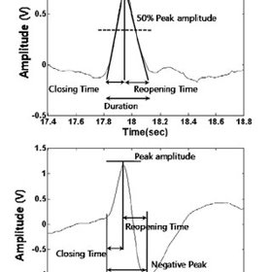

Figure 1a: Blink duration and frequency detected on a plot

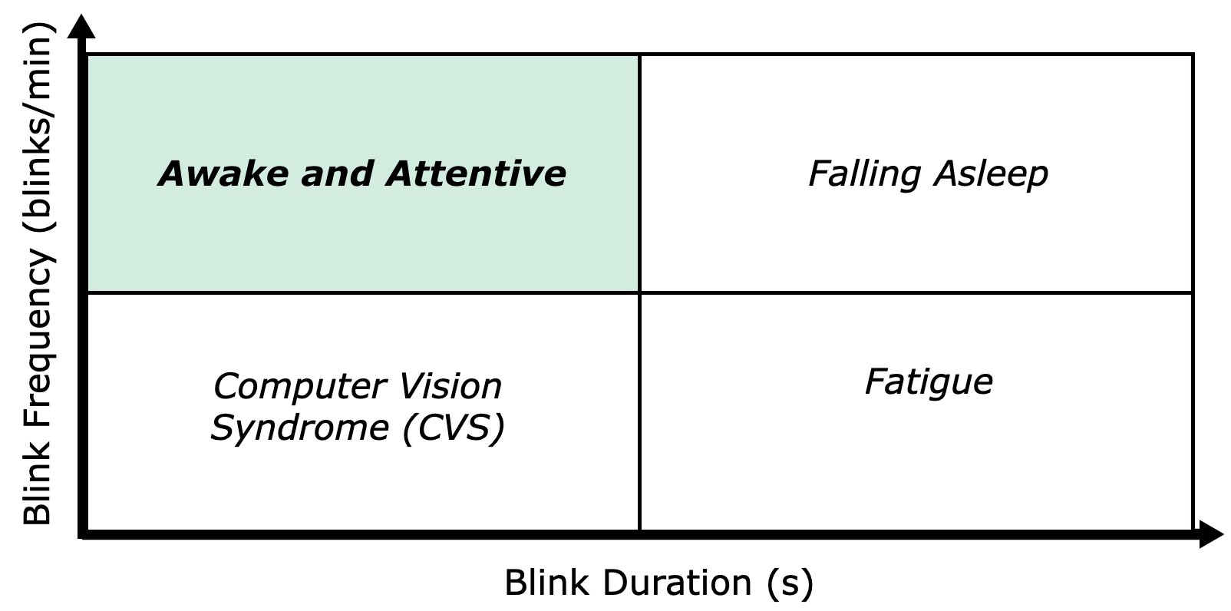

Figure 1b: The Blink Spectrum

## *D.* *Goals, Specifications and Testing Plan*

Our goal in this work is to develop a wearable solution. The key questions underlying such a device are robustness, low power consumption, and low latency. From a power consumption perspective, since we are not using cameras to sense or monitor, we will be significantly reducing the power consumption of the whole detection device. In this report, we design BLISS (Blinking Low-Power Infrared Sensing System) to be able to extract key features of your cognitive state by monitoring blink rate and blink duration at low power and with low latency. Our contributions are threefold. First, we develop a system which can detect blink frequency and blink duration. Next, we build a detection system that alerts the user of deleterious behavior. Lastly, we designed a system that is lightweight, portable and energy efficient.

Maintaining the right balance between robustness, low power consumption and low latency is crucial as it affects the overall performance and usability of the wearable solution. It’s important to note that low latency solution will require high power consumption and vice versa. Therefore, it’s important to find the right balance between power consumption and latency. The hardware selection and power design are carefully considered to minimize the power consumption whilst meeting all the specifications mentioned.

|  |  |
| --- | --- |
| Specification | Corresponding Testing Plan |
| Detect blink frequency of the user to within ±1 blink/min | Blink while varying both the frequency and durations of each blink, and check that the blinks detected by the system are within the given accuracy thresholds by manually reviewing a video of the blinking. |
| Detect blink duration of the user to within 0.1 seconds |
| Operate in a stable, indoors lighting environment | Test the system under various indoor lighting conditions and check that the consistency of accuracy is maintained. |
| Be unobtrusive to the user when collecting data | Survey users and ensure that all users did not report impaired sight. |
| Alert the user when their blink frequency is less than 12 times per minute (average blink frequency is around 12 blinks per minute) | Blink with a frequency of under 10 blinks per minute, another test with durations of over 0.5 seconds, and a final test with both low frequency and high duration. Ensure that the system flags all three behaviors. |
| Alert the user when their average blink duration is longer than 0.5 seconds (average blink duration is around 0.5 seconds) |
| Alert the user effectively yet discreetly | Activate the alert mechanism and check that it cannot be detected without touching the system. |
| Observe eye safety regulations for IR sensor | Calculate and measure the light intensity of the IR sensor and verify that it is below the safety threshold. |

*Table 1: Specifications and Testing Plan*

II. Design

## *A.* *Overview*

BLISS results in a low-cost, energy efficient, and lightweight design that detects blink frequency and duration while communicating wirelessly using Bluetooth using an IR sensor. IR sensor is the lightest and least expensive sensor from the four different methods described above such as camera, EEG, and EOG. We considered using these methods at least once in our project but due to their characteristics, we opted out and finalized IR sensing for blink detection. The information will be transmitted to an app on a phone using Bluetooth. The app will be used to alert the user using auditory means.

Using a camera to detect blinks is not only more costly, but also adds a lot more weight to the system. The design needs a lot more image/video processing and that would increase the complexity of the design. Adding a camera onto a pair of glasses can also obstruct the view like it did in iLid. Next, we investigated using EEG sensors to detect blinks. EEG electrodes are very expensive. The one mentioned earlier in similar solutions uses an EEG sensor that is around $300. EEG sensors are meant to go around the head as shown in Appendix A1. This can cause discomfort to the user if this is meant to be used in everyday daily uses. Next, we also explored EOG. They are also not low-cost nor lightweight, and they also use electrodes to measure voltage near the eyes. Appendix A2 gives more information on how EOG functions. Although all these methods detect blinks, our goal is to present a device that is low-cost, lightweight, and energy efficient. Using an IR sensor helps us achieve our goal. IR sensors transmit a signal and receive the reflection of IR wavelengths to detect blinks. IR waves are harmful to the human eye if used excessively. We aim to use Near-Infrared (NIR) wavelengths in our project. There is a sensor that emits and receives 950nm of NIR wavelengths. Currently, that is the sensor that we are planning to use, but we may be switching to another IR sensor that emits lower NIR wavelengths which is safer for the eye and is satisfactory to the E&HS standards.

Next, we needed to figure out a way to alert the user. There are three ways to alert the user: visual, auditory, and sensory. From MDR, we switched from using a vibration motor to an app for sending messages, hence we are using auditory means. Although, sensory touch is the best way a user can be alerted, since the touch on their skin produces a reaction which will alert the user of their current state. For the future, this is something we are looking to improve for a better and safer experience for the user.

System specifications are not all trivial to accomplish, and some of them directly impact the performance of other aspects of the system. For example, the specification that says that the device will work indoors allows for various lighting conditions, from dark to brightly lit rooms. This will impact the accuracy of the blink detection, since the device must be calibrated to work in all conditions. Another specification that will have a direct tradeoff is the unobtrusive requirement. Placing the IR sensor directly in front of the eye will have much better accuracy, but it will be in the way of the user. Conversely, placing the IR sensor outside the field of view of the user will ensure a minimal obstruction to their vision but the angle of the sensor would produce a noisier measurement, reducing the accuracy of the blink detection frequency and duration.

To get to a clear vision of the design, let’s discuss the hardware and software block diagrams.

The hardware block diagram is shown in Figure 2. There are going to be two PCBs: IR sensing and shield PCB systems. PCB1 is the shield PCB and PCB 2 is the IR sensor PCB. They both transfer data to each other with a JST connector. Then the shield PCB sends information to the MCU on the feather board where it gets processed and then that information gets transferred to the smartphone app using Bluetooth on the feather board. IR sensor PCB has a transmitter and receiver that will transmit a wavelength in the NIR spectrum, and the receiver will detect the reflected wavelength. IR sensors are soldered onto the PCB 2.

The software block diagram shown in Figure 3 has two main components, the application running on the eyeblink detection PCB and the application running on the wearable device. The eyeglass system is where the bulk of the processing happens, collecting the voltage data read from the IR sensor and analyzing the information using a custom algorithm. The algorithm extracts a simple moving average, standard deviation, and a weighted moving average to act as a threshold to count blink duration. Basic blink information is extracted from the data, such as average frequency and duration, so that the results are ready to be transmitted via Bluetooth to the mobile system. Once this data is received on the smart device, it will be displayed on the screen in an easily digestible manner. The application will also decide if the user’s blinking behavior is concerning, and the vibration feature will be appropriately activated.

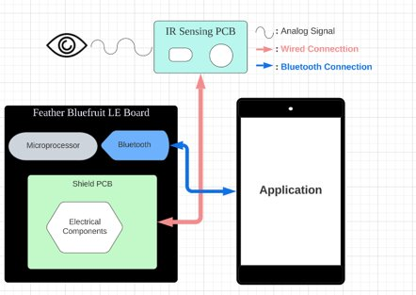

Figure 2: Hardware Block Diagram.

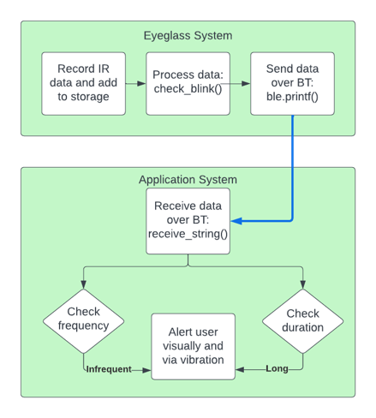

Figure 3. Software Block Diagram

## *B.* *Block 1*

The first block of the block diagram is the detection systems PCB. The microcontroller with its built-in Bluetooth module and the battery will be interconnected on the PCB. The microcontroller onboard the eyeglasses system acts as the channel of communication between the IR sensor and the Bluetooth modules, reading the measurements from the wired IR sensor and transmitting the processed data at appropriate times. The microcontroller will process data continuously as it is sampled from the IR sensors, and the results will be sent to the mobile application via Bluetooth. Our intended microcontroller for this block is the Adafruit Feather M0, which is quite small, lightweight, and energy efficient. There is a Bluetooth module built into the M0 which we will use to communicate with the application. Lastly, to power the whole block and the IR sensors, coin batteries of 3V would be used. The coin batteries that we chose provide sufficient power for our purposes, are lightweight (~0.7 grams), and are also small and can fit onto the PCB.

## *C.* *Block 2*

These three things, the microprocessor, Bluetooth module, and power supply are shared between both PCBs. Using the Bluetooth module and a MCU, we are aiming to transfer the data wirelessly to the app; the data will be processed on the MCU and analyzed according to the blink spectrum to understand the blink activity. The analysis will be displayed on the app. The user will be alerted via the auditory messages when the blinking behavior is not in the safe area of the blink spectrum. Currently, we have the app saying if you are in “Good”, “CVS”, “Fatigued”, “Sleepy” range. This way the user can know what spectrum they are in. Although, we believe sensory means would be a better approach to silently let the user know. We will be working on that for next time.

IIi. THE PROTOTYPE

## *A.* *Prototype Overview*

The FPR prototype of the system is fully contained in a 3D-printed enclosure which houses hardware from both system components described in the FPR deliverables. The IR sensors are mounted on the sensor PCB which slots into the frame, and are wired via JST connector to the shield PCB which connects to the proper pins on the Adafruit Feather M0. The Feather M0 has a Bluetooth Low Energy module and is powered by a single 3.7V Li-Po battery. The Android app is used to communicate the user’s blink data and behavior such as fatigue, Computer Vision Syndrome (CVS), or falling asleep. Anomalous behavior will be alerted by vibration as well as an auditory cue. The form factor of the standalone system has been refined in this final version of our prototype, with the 3D-printed encasing hiding most of the wiring from the user.

## *B. List of Hardware and Software*

An updated list of components is provided that were used to create the prototype presented in the CDR. Currently in this design, IR sensor of 810nm wavelength is used. Adafruit Feather M0 is used as the microcontroller. The Bluetooth Low Energy (BLE) module is used to communicate with an Android phone which displays the user blink data as well as notifies them as to whether their blinking is irregular. Further, it also indicates the type of symptoms the user has (refer to the blink spectrum).

* Software justification
  + Thus far in our project, our software contains the programming for the Android application as well as the microcontroller, which was originally written in C then rewritten for the Arduino IDE. The final system uses an Adafruit MCU which can be flashed using the Arduino IDE and will communicate with the application via Bluetooth on its own.
  + The data processing is done using a custom algorithm designed specifically for this project, which compares smoothed raw IR sensor data against its weighted moving average to determine if the user is in a blinking state. The duration and frequency of the user’s blinks are recorded internally, and those results are relayed to the user's Android phone using Bluetooth. This was achieved through the use of GATT Services and Characteristics protocol for the BLE module. Furthermore, an Android application also needed to be created, which we chose Thunkable for their easy BLE interfacing.
* Hardware justification
  + 810nm IR emitter and receiver
    - Reflective sensors TCRT5000 and RCT5000L are used for blink detection. Combined sensors are 10.2 x 5.8 x 7 mm in size and operate at 810 nm. Their daylight blocking filter helps us with testing environment selection and allows the user to use the system during daytime. The TCRT5000 from Vishay Semiconductor Opto Division costs $2.93, allowing us to minimize the overall cost of the wearable.
    - Main reason for choosing this was its low current draw of 100mA and its operating temperature range of –20C and 80C.
  + Microcontroller Board
    - As we want the board and chip to consume low power, low cost, and be light weight, we chose Adafruit Feather M0 Basic Proto – ATSAMD21 Cortex M0. It uses Bluetooth Low Energy (BLE) NRF51822 module and has a built-in USB and battery charging port. It was chosen primarily for its low current draw of ~7 mA (20uA when in sleep mode and 7mA when in idle mode) and its low cost of $19.95. When attached to sensors, its typical usage with peripherals running is between 25 mA and 80 mA.

## *C. Custom Hardware (PCB)*

In our final design of our system, we have two PCBs: a sensor PCB and a shield PCB. The sensor PCB has our IR emitter and receiver soldered on, as well as a JST connector port that will link to the shield PCB with an identical port. The shield PCB connects the wires from the connector to the proper pins on the microcontroller, as well as a surface-mounted resistor for the emitter LED. The PCBs have eliminated the need for exposed wires in our final prototype. The PCBs are about 3 grams in total, which is insignificant compared to the total weight of the system. They are inside the closure of the 3D-printed box.

## *D. Prototype Functionality*

The FPR prototype is the final version of our system with all the hardware components in a 3D-printed case. The IR sensor board sits on the inside of the frame and captures the users’ blinks while the battery and microcontroller sit inside a box mounted on the side of the frame. The IR data is sent to be processed by the microcontroller (ATSAMD21 Cortex M0) on the Adafruit Feather Board. When the signal information is processed, we store the number of blinks the user had in the last 60 seconds of their session. This with the average blink duration helps identify where the user lies on the blink spectrum. By identifying the condition of the user, we display the blink duration, frequency, as well as the condition on the smartphone app in real-time. Depending on the identified condition of the user, other than a normal behavior from the user, a vibration and sound will be emitted from the smartphone to alert the user of their condition.

## *E. Prototype Performance*

As demonstrated in the FPR presentation, the system works in an indoor environment without an abundance of false positives or negatives. We achieved the accuracy goal we promised in our FPR deliverables of 90% accuracy. However, we could only hit this accuracy when the test subject was not moving their head around, which we deemed acceptable as our use cases should not have users moving their heads around too much. All these results are delivered using only 30.8 mA of current as Bluetooth was on and all the sensors were on. This gives us a power consumption of 0.114 W. Given the 550 mAh power Li-Po battery we have, this gives us a system lifetime of 17.857 hours. The standalone system, powered by a Li-Po battery, maintains a stable Bluetooth connection with the app throughout its operation.

The alert mechanism is also triggered appropriately, when the measured average blink frequency is below 12 blinks per minute, or the average blink duration is below 0.5 seconds. We chose 12 blinks per minutes as the threshold as a study from 2017 [14] concluded that the normal spontaneous blink rate is between 12 and 15 per min. Similarly, 0.5 seconds was chosen as the blink duration threshold based on a study from 2011 which reported episodes of microsleep as eye closures > 500 ms [15]. For the user to know what their behavior is being flagged for, there are three different vibration patterns for each harmful condition.

IV: CONCLUSION

In conclusion, BLISS is an important development in the realm of wearable technology for cognitive state monitoring. BLISS has the potential to prevent drowsiness-related accidents, lower the prevalence of computer vision syndrome, and improve general productivity and wellbeing by making it possible to accurately and non-intrusively monitor blink frequency and duration. The development of low-cost, low-power solutions employing easily accessible electrical components is demonstrated by this ground-breaking system, paving the way for future developments in wearable technology and healthcare monitoring.

V: ACKNOWLEDGEMENTS

BLISS would not have been at this stage without the help of many people. Special thanks to Professor Qiangfei Xia for guiding us through developing this product. Thank you to Prof. Gummeson and Prof. Siqueira for evaluating our project and providing invaluable feedback. Special shoutout to our course coordinators, TAs, and M5 staff for all their help.

References

[1] F. John Dian, R. Vahidnia and A. Rahmati, "Wearables and the Internet of Things (IoT), Applications, Opportunities, and Challenges: A Survey," in *IEEE Access*, vol. 8, pp. 69200-69211, 2020, doi: 10.1109/ACCESS.2020.2986329.

[2] R. Saeedi, K. Sasani, S. Norgaard and A. H. Gebremedhin, "Personalized Human Activity Recognition using Wearables: A Manifold Learning-based Knowledge Transfer," *2018 40th Annual International Conference of the IEEE Engineering in Medicine and Biology Society (EMBC)*, 2018, pp. 1193-1196, doi: 10.1109/EMBC.2018.8512533.

[3] De Zambotti M, Rosas L, Colrain IM, Baker FC. The sleep of the ring: comparison of the OURA sleep tracker against polysomnography. Behav. Sleep Med. doi:10.1080/15402002.2017.1300587 (2017) (Epub ahead of print).

[4] Topouchian J, Agnoletti D, Blacher J et al. Validation of four devices: Omron M6 Comfort, Omron HEM-7420, Withings BP-800, and Polygreen KP-7670 for home blood pressure measurement according to the European Society of Hypertension International Protocol. Vasc. Health Risk Manag. 10, 33 (2014).

[5] Bhaskar S, Hemavathy D, Prasad S. Prevalence of chronic insomnia in adult patients and its correlation with medical comorbidities. J Family Med Prim Care. 2016 Oct-Dec;5(4):780-784. doi: 10.4103/2249-4863.201153. PMID: 28348990; PMCID: PMC5353813.   
[6] “CDC - about Our Program - Sleep and Sleep Disorders.” Centers for Disease Control and Prevention, Centers for Disease Control and Prevention, 5 June 2017, <https://www.cdc.gov/sleep/about_us.html#:~:text=About%2070%20million%20Americans%20suffer,costs%2C%20and%20lost%20work%20productivity>.

[7] Suzanne E. Goldman, Sonia Ancoli-Israel, Robert Boudreau, Jane A. Cauley, Martica Hall, Katie L. Stone, Susan M. Rubin, Suzanne Satterfield, Eleanor M. Simonsick, Anne B. Newman, for the Health, Aging and Body Composition Study, Sleep Problems and Associated Daytime Fatigue in Community-Dwelling Older Individuals, *The Journals of Gerontology: Series A*, Volume 63, Issue 10, October 2008, Pages 1069–1075,<https://doi.org/10.1093/gerona/63.10.1069>

[8] “Drowsy Driving.” *NHTSA*,<https://www.nhtsa.gov/risky-driving/drowsy-driving>.

[9] Wundersitz L. Driver distraction and inattention in fatal and injury crashes: Findings from in-depth road crash data. Traffic Inj Prev. 2019;20(7):696-701. doi: 10.1080/15389588.2019.1644627. Epub 2019 Aug 13. PMID: 31408358.

[10] Salla J, Michel G, Pingault JB, Lacourse E, Paquin S, Galéra C, Falissard B, Boivin M, Tremblay RE, Côté SM. Childhood trajectories of inattention-hyperactivity and academic achievement at 12 years. Eur Child Adolesc Psychiatry. 2016 Nov;25(11):1195-1206. doi: 10.1007/s00787-016-0843-4. Epub 2016 Mar 26. PM**ID: 27017347.**

[11] Logaraj, M et al. “Computer vision syndrome and associated factors among medical and engineering students in chennai.” *Annals of medical and health sciences research* vol. 4,2 (2014): 179-85. doi:10.4103/2141-9248.129028

[12] Watson, Stephanie. “Computer Vision Syndrome: Causes, Symptoms and Treatments.” *WebMD*, WebMD, 29 Nov. 2021, <https://www.webmd.com/eye-health/computer-vision-syndrome>.

[13] Bluetooth Transceiver Module, LYRA P, Data Sheet, *Digikey*, <https://www.lairdconnect.com/documentation/product-brief-lyra-series>.

[14] Abusharha, Ali A. “Changes in Blink Rate and Ocular Symptoms during Different Reading Tasks.” Clinical Optometry, U.S. National Library of Medicine, 20 Nov. 2017, https://www.ncbi.nlm.nih.gov/pmc/articles/PMC6118863/#:~:text=It%20has%20been%20reported%20that,between%2012%20and%2015%2Fmin.&text=Other%20studies%20showed%20that%20the,from%202%20to%2010%20s.&text=A%20mean%20blink%20rate%20of,been%20reported%20under%20relaxed%20conditions.

[15] Wang, Yanfang, et al. “Blink Frequency and Duration during Perimetry and Their Relationship to Test–Retest Threshold Variability.” Iovs.arvojournals.org, https://iovs.arvojournals.org/article.aspx?articleid=2188061.

Appendix

## *A.* *Design Alternatives*

A1: One of the first design ideas which we heavily considered was using an EEG (electroencephalogram) sensor to detect the blinks of the user, which we showed to be possible. An EEG sensor measures electrical activity in the brain by taking measurements from the surface of the scalp via metal electrodes. We experimented using our advisor’s personal EEG headset which he graciously lent to us, but we ultimately decided that building the entire project on the device was unrealistic. It was prohibitively expensive, as well as being extremely inconsistent with measurements and being difficult to set up properly, and it was also uncomfortable to wear for long periods of time. Figure 4 below shows how an EEG sensor is placed on a user head. It can be uncomfortable.

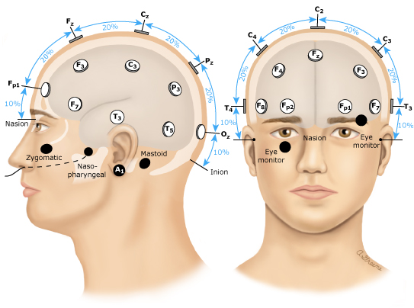

Figure 4: EEG sensors placements on a user’s head

A2: EOG is a technique that measures the corneo-retinal standing potential which can be measured between the front and the back of the human eye. The resulting signal is called the electrooculogram (EOG). Figure 5 shows the placement of the electrodes near your eye to measure the potential.

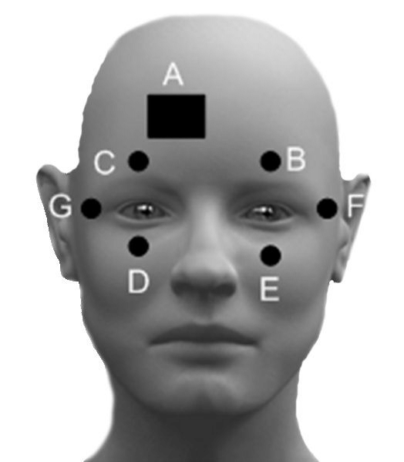

Figure 5: The placement of electrodes in an EOG system

## *B.* *Technical Standards*

Bluetooth is our method of communication between the two PCB systems in our project, used solely for the transfer of data. Bluetooth has a well-established presence as a highly reliable, efficient form of wireless data transmission, and there are many PCB modules to choose from that can implement it. This allows us to minimize the power and weight cost of wireless communication.

## *C.* *Testing Methods*

The primary experiment is testing the IR sensor and the blink detection algorithm by having the user blink in a predetermined manner and seeing if the system will correctly identify the behavior. The various blinking behaviors will be a combination of low/high blinking frequency and low/high blinking duration. The purpose of this experiment is to test the accuracy of the IR sensor and the validity of the algorithm, ensuring that the output is not garbage for real data.

The secondary experiment will be sending packets of known data over Bluetooth between the two PCBs and ensuring that the data is transferred accurately, without loss, and in real time.

## *D.* *Project Expenditures*

At the end of the year, we have $78.86 remaining. A single copy of our final prototype costs $46.95. Our breakdown over the whole year is the following:

* MDR: $58.35
* CDR: $139.98
* FPR: $222.81

## *E.* *Project Management*

We have a Discord server. We have separate channels in the server for each topic; this makes our conversation organized. The team is working well; we meet at least once a week for at least an hour. When necessary, we meet every day of the week for a few hours (i.e., during PDR). Our team is very versatile; in time of need, if one member is very busy, the rest of the team is ready to take on their part to make sure the work gets done on time despite having roles assigned for each member. The week before the PDR report was due, almost all the members had exams and other extracurriculars planned in that week which made each of us extremely busy. However, when we met to finish the PDR report, we were all able to help each other out on each other’s topics and complete the assignment.

Taisuke Miyamoto is a CE responsible for the algorithms and software coding of the system.

Tergel Molom-Ochir is an EE who oversees logistics. He will be working on the circuits, hardware and sensors.

Heta Shah is an EE responsible for creating the PCBs for the design. She will be responsible for doing multiple revisions of the PCBs.

Sashank Rao is a CE responsible for the embedded software design development.

## *F.* *Beyond the Classroom*

Taisuke will need to learn how to combine high-level programming concepts with low-level hardware, while also considering a strict energy budget for the processor. In the research phase of the project, he polished his skills in finding project ideas and brainstorming new approaches to solving problems that others had encountered before. Finding a suitable project idea was one of the main challenges facing the group and keeping a realistic scope for the project while being interested enough to be motivated for the project was a difficult task. This experience will prove to be a valuable experience in my future work as well.

Tergel needed to improve his problem statement writing skills as a result of this project so far. In terms of resources, Google Scholars, PubMed, and ACM webpages have been useful. As he is the hardware person of the group, he also had to learn how to read specification sheets and think about the design or integration of the whole device.

Heta is taking the PCB class to help her in creating PCBs for the design. Hackathons have been also very helpful for her to understand these sensor systems. There has been a lot of research involved in not only getting this project working but also getting to this project. Understanding the logistics, complexity, keeping the budget in mind, understanding the skills that the team has, and the overall picture has made her understand how a project works from start to finish—brainstorming to final product. In her opinion, SDP gives that experience to her. She believes that regardless of what career anyone goes in, SDP serves as a downscaled version of the process many companies go through to get their product in the market.

Sashank will need to polish how to properly implement all the modules that go on the glasses and properly communicate between the glasses and the user display mechanism. However, with experiences like JDP and the papers read in class 597SD, his understanding for embedded systems programming has only refined his skills as an embedded system programmer. These experiences have also allowed him to have a more level headed approach to problems and helped with contributing to the team. In terms of resources, zotero has been useful in his research on the topic especially when brainstorming for an idea was involved.